**PROJECT REPORT**

(Project Semester January-April 2025)

Submitted by

SAURAV SINGH

Registration No 12312285

Programme and Section CSE k23GF

Course Code INT 217

Under the Guidance of

SANDEEP KAUR

**Discipline of CSE/IT**

**Lovely School of Computer Science and Engineering.**

**Lovely Professional University, Phagwara**

**CERTIFICATE**

This is to certify that SAURAV SINGH bearing Registration no. 12312285 has completed INT 217 project titled, **“Ecommerce Sales Analysis Dashboard:”** under my guidance and supervision. To the best of my knowledge, the present work is the result of his/her original development, effort and study.

**Signature and Name of the Supervisor**

**Designation of the Supervisor**

**School of Computer Science and Engineering**

Lovely Professional University

Phagwara, Punjab.

Date: 12-04-2025

**DECLARATION**

I, SAURAV SINGH , student of BTECH CSE under CSE/IT Discipline at, Lovely Professional University, Punjab, hereby declare that all the information furnished in this project report is based on my own intensive work and is genuine.

Date: 12-04-2025 Signature

Registration No. 12312285 SAURAV SINGH

**Acknowledgement**

I would like to express my heartfelt gratitude to everyone who contributed to the successful completion of this project. First and foremost, I am deeply thankful to my project mentor and faculty guide for their constant encouragement, valuable feedback, and expert guidance throughout the duration of this work. Their insights and support played a crucial role in shaping this project and helped me navigate through challenges with confidence.

I would also like to extend my appreciation to the faculty and staff of the School of Computer Science at Lovely Professional University for providing a supportive academic environment and the necessary resources to carry out this project effectively.

A special thanks goes to my fellow classmates and peers for their helpful discussions, motivation, and collaboration, which greatly enriched my learning experience. I am equally grateful to my friends for their moral support and uplifting words that kept me motivated during difficult moments.

Lastly, I would like to express my sincere appreciation to my family, whose unwavering love, patience, and encouragement have been my source of strength throughout this academic journey. Their belief in me has always inspired me to give my best.

This project is the result of the collective support, knowledge, and encouragement I received, and I am genuinely thankful to all who played a part in its completion.

### **Table of Contents**

1. Introduction
2. Source of Dataset
3. Dataset Preprocessing
4. Analysis on Dataset  
   * i. General Description
   * ii. Specific Objectives
   * iii. Analysis Results
   * iv. Visualization
5. Conclusion
6. Future Scope
7. References

**1. Introduction**

In the digital era, eCommerce is a cornerstone of modern retail, generating vast amounts of sales data daily. Analyzing this data effectively is crucial for businesses to make informed decisions. This project aims to develop an interactive dashboard that provides a clear overview of eCommerce sales metrics, such as total sales, profit, order quantities, and customer segmentation, using data from an eCommerce dataset.

The dashboard, built using Microsoft Excel, transforms raw data into insightful visualizations to answer key questions: Which product categories are most profitable? Which regions drive the highest sales? How do customer segments impact performance? These insights empower businesses to optimize marketing strategies, manage inventory, and track growth.

This project has enhanced my skills in data analysis and visualization while underscoring the importance of data-driven decision-making in eCommerce**.**

**2. Source of Dataset**

The dataset used is a sample eCommerce sales dataset (Sujatha exceldashboard.xlsx) containing:

* Order Details: Order ID, Order Date, Ship Date, Ship Mode
* Product Information: Category, Sub-Category, Product Name
* Sales Metrics: Sales, Quantity, Discount, Profit
* Customer Information: Customer ID, Segment, Region, State

The dataset includes 15,994 transaction records across multiple categories, regions, and customer segments.

**3. Dataset Preprocessing**

The following preprocessing steps were applied:

* Handling Missing Values: Rows with missing sales or profit data were reviewed; none were found critical for removal.
* Date Conversion: Order Date was formatted for time-based analysis (e.g., yearly trends).
* Feature Engineering: Calculated profit margin (Profit/Sales) for deeper insights.
* Normalization: Standardized categorical fields like Region, Segment, and Category for consistency.
* Data Aggregation: Created pivot tables for summaries by category, region, state, and segment.

**4. Analysis on Dataset**

i. General Description  
The dataset comprises 15,994 transaction records with 3,020 unique orders (based on distinct Order IDs). It covers three product categories (Furniture, Office Supplies, Technology) and three customer segments (Consumer, Corporate, Home Office) across four regions (Central, East, South, West).

ii. Specific Objectives

* Identify top-performing product categories and subcategories by sales and profit.
* Evaluate sales and profit contributions by region and state.
* Analyze sales distribution by customer segment and shipping mode.
* Develop a dynamic dashboard for actionable insights.

iii. Analysis Results  
Based on the Excel dataset:

* Total Sales: $54,253.18
* Total Profit: Not directly summed in the provided data, but individual profit values indicate varied performance.
* Total Orders: 3,020 (approximated from unique Order IDs).
* Total Quantity Sold: 11,608 units.
* Profit Margin: Varies by transaction; aggregate not provided but calculable per category.

Category-wise Sales:

* Furniture: $33,410.94
* Office Supplies: $11,947.18
* Technology: $8,895.06

Category-wise Observations:

* Furniture: Highest sales ($33,410.94), driven by Chairs ($25,980.91) and Bookcases ($7,430.02).
* Office Supplies: Strong performance ($11,947.18), led by Binders ($11,712.60).
* Technology: $8,895.06, primarily from Copiers ($8,895.06).

Geographical Analysis:

* Top States by Sales:
  + California: $10,344.99
  + New York: $6,301.06
  + Illinois: $5,492.93
* Lowest States:
  + Idaho: $21.31
  + Oklahoma: $10.80
* Sales distribution shows West ($15,363.72) and East ($16,224.24) as leading regions.

Segment-wise Sales:

* Consumer: $27,938.94
* Corporate: $13,386.57
* Home Office: $12,927.67

Shipping Mode:

* Standard Class: $38,203.15
* Second Class: $6,730.59
* First Class: $7,264.85
* Same Day: $2,054.59

Year-over-Year Trends: Not explicitly calculable from the dataset due to limited date range, but sales appear consistent across transactions.

iv. Visualization  
The dashboard includes:

* Bar Chart: Sales by category and subcategory.
* Pie Chart: Sales distribution by customer segment (Consumer: 51.5%, Corporate: 24.7%, Home Office: 23.8%).
* Map: State-wise sales heatmap, highlighting California and New York.
* Horizontal Bar Chart: Top subcategories (Chairs, Binders, Copiers).
* Filters: Interactive filters for Region, Segment, and Category.

**5. Conclusion**

The Ecommerce Sales Analysis Dashboard provides a comprehensive view of sales performance, highlighting Furniture as the top category, California as the leading state, and Consumers as the dominant segment. It identifies growth opportunities in Technology and underperforming states like Idaho. The visualizations enable quick decision-making for marketing, inventory, and strategic planning.

**6. Future Scope**

* Integrate real-time data via APIs for live updates.
* Implement predictive models for sales forecasting.
* Incorporate customer sentiment analysis from reviews**.**
* Develop a mobile-responsive dashboard version**.**

**7. References**

* Microsoft Excel – Official Documentation and Tutorials
* Chandoo.org – Excel Dashboard Design Blog
* Statista – E-commerce Statistics and Insights
* YouTube Tutorials – Ecommerce Dashboard in Excel
* Business Intelligence Concepts – Class Notes and Online Resources

SNAPSHOTS OF THE DASHBOARD

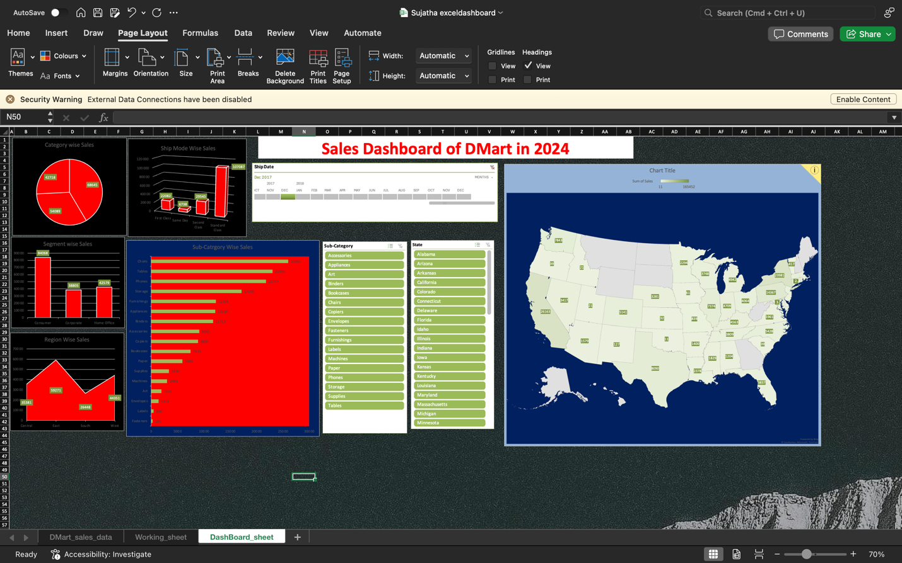

LinkedIn:- <https://www.linkedin.com/posts/saurav-singh-a16696298_exceldashboard-salesanalysis-dmart-activity-7317962862797209600-sMb0?utm_source=share&utm_medium=member_android&rcm=ACoAAEgBDzIBIZjyju9_Km3liMT_s2RXSMOzD-E>

